Name : Vivek Singh
RegNumber : 230905408
Roll Number: A50

Lab 5: Developing Web Application using Django-Part I

Question:

1) Develop a simple web page to perform basic arithmetic operations. Take two integer inputs from the user, select the operation to be performed using a dropdown. Include a button “Calculate” to perform the selected operation, and then display the result in the same web page.

forms.py
from django import forms

class CalculatorForm(forms.Form):
number1 = forms.IntegerField(
label="First Number",
widget=forms.NumberInput(attrs={
'class': 'form-control',
'placeholder': 'Enter first number'
})
)

number2 = forms.IntegerField(
label="Second Number",
widget=forms.NumberInput(attrs={
'class': 'form-control',
'placeholder': 'Enter second number'
})
)

OPERATION_CHOICES = [
('+', 'Addition (+)'),
('-', 'Subtraction (−)'),
('*', 'Multiplication (×)'),
('/', 'Division (÷)'),
]

operation = forms.ChoiceField(
choices=OPERATION_CHOICES,
widget=forms.Select(attrs={'class': 'form-control'})
)
views.py
from django.shortcuts import render
from .forms import CalculatorForm

def calculator_view(request):
result = None
error = None
num1 = None
num2 = None
op = None

if request.method == 'POST':
form = CalculatorForm(request.POST)
if form.is_valid():
num1 = form.cleaned_data['number1']
num2 = form.cleaned_data['number2']
op = form.cleaned_data['operation']

try:
if op == '+':
result = num1 + num2
elif op == '-':
result = num1 - num2
elif op == '*':
result = num1 * num2
elif op == '/':
if num2 == 0:
error = "Division by zero is not allowed!"
else:
result = num1 / num2 # float division
except Exception as e:
error = str(e)
else:
form = CalculatorForm()

context = {
'form': form,
'result': result,
'error': error,
'num1': num1,
'num2': num2,
'operation': op,
}
return render(request, 'calculator/calculator.html', context)
templates/calculator/calculator.html
<!DOCTYPE html>
<html lang="en">
<head>
<meta charset="UTF-8">
<meta name="viewport" content="width=device-width, initial-scale=1.0">
<title>Simple Calculator</title>
<link href="https://cdn.jsdelivr.net/npm/bootstrap@5.3.0/dist/css/bootstrap.min.css" rel="stylesheet">
<style>
body { background-color: #f0f4f8; padding: 30px; }
.container { max-width: 500px; background: white; padding: 30px; border-radius: 12px; box-shadow: 0 4px 15px rgba(0,0,0,0.1); }
h2 { text-align: center; color: #2c3e50; margin-bottom: 30px; }
.result-box { font-size: 1.6rem; font-weight: bold; text-align: center; padding: 20px; border-radius: 8px; margin: 25px 0; }
.success { background-color: #d4edda; color: #155724; }
.danger { background-color: #f8d7da; color: #721c24; }
</style>
</head>
<body>

<div class="container">
<h2>Basic Arithmetic Calculator</h2>

<form method="post">
{% csrf_token %}

<div class="mb-3">
<label class="form-label">First Number</label>
{{ form.number1 }}
</div>

<div class="mb-3">
<label class="form-label">Second Number</label>
{{ form.number2 }}
</div>

<div class="mb-4">
<label class="form-label">Operation</label>
{{ form.operation }}
</div>

<div class="text-center">
<button type="submit" class="btn btn-primary btn-lg px-5">Calculate</button>
</div>
</form>

{% if result is not None %}
<div class="result-box success">
{{ num1 }} {{ operation }} {{ num2 }} = {{ result }}
</div>
{% endif %}

{% if error %}
<div class="result-box danger">
{{ error }}
</div>
{% endif %}

</div>

<script src="https://cdn.jsdelivr.net/npm/bootstrap@5.3.0/dist/js/bootstrap.bundle.min.js"></script>
</body>
</html>
urls.py (in app)
from django.urls import path
from . import views

urlpatterns = [
path('calculator/', views.calculator_view, name='calculator'),
]

output:
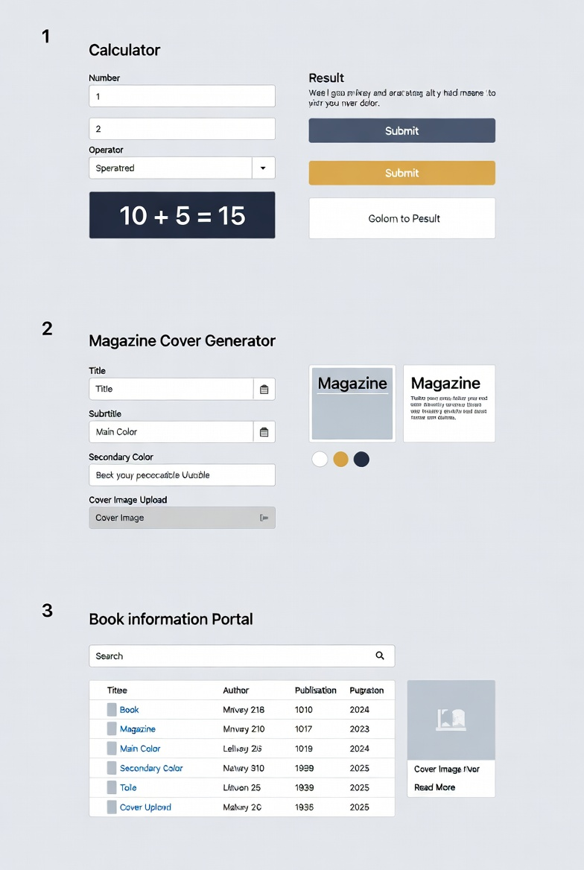
Q2) Develop a simple web form that generates the front cover for a magazine. The form should provide the options for selecting the image, background color, changing font size, color etc. Input messages must be taken from the user so as to display it on the front cover with legible font family and font size. The front cover developed should be proportionate to the web page size. Place the
css files inside static folder.

forms.py
from django import forms

class MagazineCoverForm(forms.Form):
title = forms.CharField(max_length=100, widget=forms.TextInput(attrs={
'class': 'form-control', 'placeholder': 'Magazine Title'}))

subtitle = forms.CharField(max_length=200, required=False, widget=forms.TextInput(attrs={
'class': 'form-control', 'placeholder': 'Subtitle / Tagline'}))

main_text = forms.CharField(widget=forms.Textarea(attrs={
'class': 'form-control', 'rows': 3, 'placeholder': 'Main headline / story text'}))

bg_color = forms.CharField(
initial='#ff3366',
widget=forms.TextInput(attrs={'class': 'form-control', 'type': 'color'}))

text_color = forms.CharField(
initial='#ffffff',
widget=forms.TextInput(attrs={'class': 'form-control', 'type': 'color'}))

font_size_title = forms.IntegerField(
initial=48, min_value=24, max_value=90,
widget=forms.NumberInput(attrs={'class': 'form-control'}))

views.py
from django.shortcuts import render
from .forms import MagazineCoverForm

def magazine_cover_view(request):
cover_data = None

if request.method == 'POST':
form = MagazineCoverForm(request.POST)
if form.is_valid():
cover_data = form.cleaned_data
else:
form = MagazineCoverForm()

return render(request, 'magazine/cover_generator.html', {
'form': form,
'cover': cover_data,
})
templates/magazine/cover_generator.html

<!DOCTYPE html>
<html lang="en">
<head>
<meta charset="UTF-8">
<meta name="viewport" content="width=device-width, initial-scale=1.0">
<title>Magazine Cover Generator</title>
<link href="https://cdn.jsdelivr.net/npm/bootstrap@5.3.0/dist/css/bootstrap.min.css" rel="stylesheet">
<style>
body { background: #e9ecef; padding: 20px; font-family: Arial, sans-serif; }
.split { display: flex; gap: 30px; flex-wrap: wrap; }
.form-side { flex: 1; min-width: 380px; }
.preview-side { flex: 1; min-width: 400px; }
.magazine-preview {
width: 100%; max-width: 420px;
aspect-ratio: 2 / 3;
margin: 0 auto;
border: 12px solid #222;
border-radius: 12px;
overflow: hidden;
box-shadow: 0 10px 30px rgba(0,0,0,0.3);
position: relative;
font-family: 'Georgia', serif;
}
.preview-content {
position: absolute;
inset: 0;
padding: 35px;
display: flex;
flex-direction: column;
justify-content: space-between;
text-align: center;
}
.title { font-weight: bold; line-height: 1.1; margin: 0; }
.subtitle { font-size: 1.4rem; margin: 10px 0 25px; opacity: 0.9; }
.main-text { font-size: 1.8rem; line-height: 1.3; }
</style>
</head>
<body>

<div class="container">
<h2 class="text-center mb-4">Magazine Front Cover Creator</h2>

<div class="split">
<div class="form-side">
<form method="post" class="card p-4 shadow-sm">
{% csrf_token %}
<div class="mb-3">{{ form.title.label_tag }} {{ form.title }}</div>
<div class="mb-3">{{ form.subtitle.label_tag }} {{ form.subtitle }}</div>
<div class="mb-3">{{ form.main_text.label_tag }} {{ form.main_text }}</div>
<div class="row">
<div class="col-md-6 mb-3">
{{ form.bg_color.label_tag }}
{{ form.bg_color }}
</div>
<div class="col-md-6 mb-3">
{{ form.text_color.label_tag }}
{{ form.text_color }}
</div>
</div>
<div class="mb-3">
{{ form.font_size_title.label_tag }}
{{ form.font_size_title }}
</div>
<div class="text-center mt-4">
<button type="submit" class="btn btn-dark btn-lg px-5">Generate Cover</button>
</div>
</form>
</div>

<div class="preview-side">
{% if cover %}
<div class="magazine-preview" style="background-color: {{ cover.bg_color }}; color: {{ cover.text_color }};">
<div class="preview-content">
<h1 class="title" style="font-size: {{ cover.font_size_title }}px;">
{{ cover.title|upper }}
</h1>

{% if cover.subtitle %}
<div class="subtitle">{{ cover.subtitle }}</div>
{% endif %}

<div class="main-text">{{ cover.main_text|linebreaksbr }}</div>
</div>
</div>
{% else %}
<div class="text-center text-muted mt-5 pt-5">
<h4>Fill the form and click Generate Cover</h4>
</div>
{% endif %}
</div>
</div>
</div>

</body>
</html>
Output:

3) Design a simple web application to provide information about a book. The home page of the application should display the cover page of the book along with three hyperlinks: Metadata, Reviews, Publisher info. Give provision to revert to home page from any other page.

views.py
from django.shortcuts import render

def home_view(request):
return render(request, 'book/home.html')

def metadata_view(request):
return render(request, 'book/metadata.html')

def reviews_view(request):
return render(request, 'book/reviews.html')

def publisher_view(request):
return render(request, 'book/publisher.html')

urls.py
from django.urls import path
from . import views

urlpatterns = [
path('', views.home_view, name='book_home'),
path('metadata/', views.metadata_view, name='metadata'),
path('reviews/', views.reviews_view, name='reviews'),
path('publisher/', views.publisher_view, name='publisher'),
]

templates/book/base.html
<!DOCTYPE html>
<html lang="en">
<head>
<meta charset="UTF-8">
<meta name="viewport" content="width=device-width, initial-scale=1.0">
<title>{% block title %}Book Information{% endblock %}</title>
<link href="https://cdn.jsdelivr.net/npm/bootstrap@5.3.0/dist/css/bootstrap.min.css" rel="stylesheet">
<style>
body { background: #f8f9fa; }
.navbar-brand { font-weight: bold; font-size: 1.5rem; }
.cover-img { max-height: 480px; object-fit: cover; border-radius: 10px; box-shadow: 0 8px 25px rgba(0,0,0,0.2); }
</style>
</head>
<body>

<nav class="navbar navbar-expand-lg navbar-dark bg-dark">
<div class="container">
<a class="navbar-brand" href="{% url 'book_home' %}">Book Portal</a>
<button class="navbar-toggler" type="button" data-bs-toggle="collapse" data-bs-target="#navbarNav">
<span class="navbar-toggler-icon"></span>
</button>
<div class="collapse navbar-collapse" id="navbarNav">
<ul class="navbar-nav ms-auto">
<li class="nav-item"><a class="nav-link" href="{% url 'book_home' %}">Home</a></li>
<li class="nav-item"><a class="nav-link" href="{% url 'metadata' %}">Metadata</a></li>
<li class="nav-item"><a class="nav-link" href="{% url 'reviews' %}">Reviews</a></li>
<li class="nav-item"><a class="nav-link" href="{% url 'publisher' %}">Publisher</a></li>
</ul>
</div>
</div>
</nav>

<div class="container my-5">
{% block content %}{% endblock %}
</div>

<script src="https://cdn.jsdelivr.net/npm/bootstrap@5.3.0/dist/js/bootstrap.bundle.min.js"></script>
</body>
</html>

templates/book/home.html
{% extends 'book/base.html' %}

{% block title %}Welcome – Atomic Habits{% endblock %}

{% block content %}
<div class="row align-items-center">
<div class="col-md-5 text-center">
<img src="https://m.media-amazon.com/images/I/81wgcld4wxL._AC_UF1000,1000_QL80_.jpg"
alt="Atomic Habits book cover" class="cover-img img-fluid">
</div>
<div class="col-md-7">
<h1 class="mb-4">Atomic Habits</h1>
<h4 class="text-muted">James Clear</h4>
<p class="lead mt-4">
A practical guide to building good habits and breaking bad ones.
</p>
<hr>
<p>Explore more information using the navigation bar above.</p>
</div>
</div>
{% endblock %}

templates/book/metadata.html
{% extends 'book/base.html' %}

{% block title %}Metadata – Atomic Habits{% endblock %}

{% block content %}
<h2>Book Metadata</h2>
<hr>
<ul class="list-group list-group-flush fs-5">
<li class="list-group-item"><strong>Title:</strong> Atomic Habits</li>
<li class="list-group-item"><strong>Author:</strong> James Clear</li>
<li class="list-group-item"><strong>ISBN:</strong> 978-0735211292</li>
<li class="list-group-item"><strong>Published:</strong> October 16, 2018</li>
<li class="list-group-item"><strong>Pages:</strong> 320</li>
<li class="list-group-item"><strong>Genre:</strong> Self-help, Personal Development</li>
</ul>
{% endblock %}
OUTPUT:

